PO2_About me

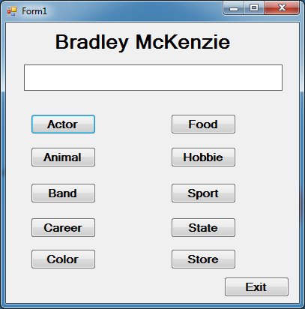

Private Sub btnActor_Click(sender As System.Object, e As System.EventArgs) Handles btnActor.Click

lblDisplay.Text = "Adam Sander"

End Sub

Private Sub Label2_Click(sender As System.Object, e As System.EventArgs) Handles lblDisplay.Click

End Sub

Private Sub btnAnimal_Click(sender As System.Object, e As System.EventArgs) Handles btnAnimal.Click

lblDisplay.Text = "Hawk"

End Sub

Private Sub btnBand_Click(sender As System.Object, e As System.EventArgs) Handles btnBand.Click

lblDisplay.Text = "Linkin Park"

End Sub

Private Sub btnExit_Click(sender As System.Object, e As System.EventArgs) Handles btnExit.Click

Application.Exit()

End Sub

Private Sub Button4_Click(sender As System.Object, e As System.EventArgs) Handles btnColor.Click

lblDisplay.Text = "Red"

End Sub

Private Sub btnFood_Click(sender As System.Object, e As System.EventArgs) Handles btnFood.Click

lblDisplay.Text = "Pizza"

End Sub

Private Sub btnHobbie_Click(sender As System.Object, e As System.EventArgs) Handles btnHobbie.Click

lblDisplay.Text = "Playing Video Games"

End Sub

Private Sub btnSport_Click(sender As System.Object, e As System.EventArgs) Handles btnSport.Click

lblDisplay.Text = "Football"

End Sub

Private Sub BtnState_Click(sender As System.Object, e As System.EventArgs) Handles btnState.Click

lblDisplay.Text = "California"

End Sub

Private Sub btnStore_Click(sender As System.Object, e As System.EventArgs) Handles btnStore.Click

lblDisplay.Text = "Game Stop"

End Sub

Private Sub btnCareer_Click(sender As System.Object, e As System.EventArgs) Handles btnCareer.Click

lblDisplay.Text = "Army Ranger"

End Sub

End Class